1. 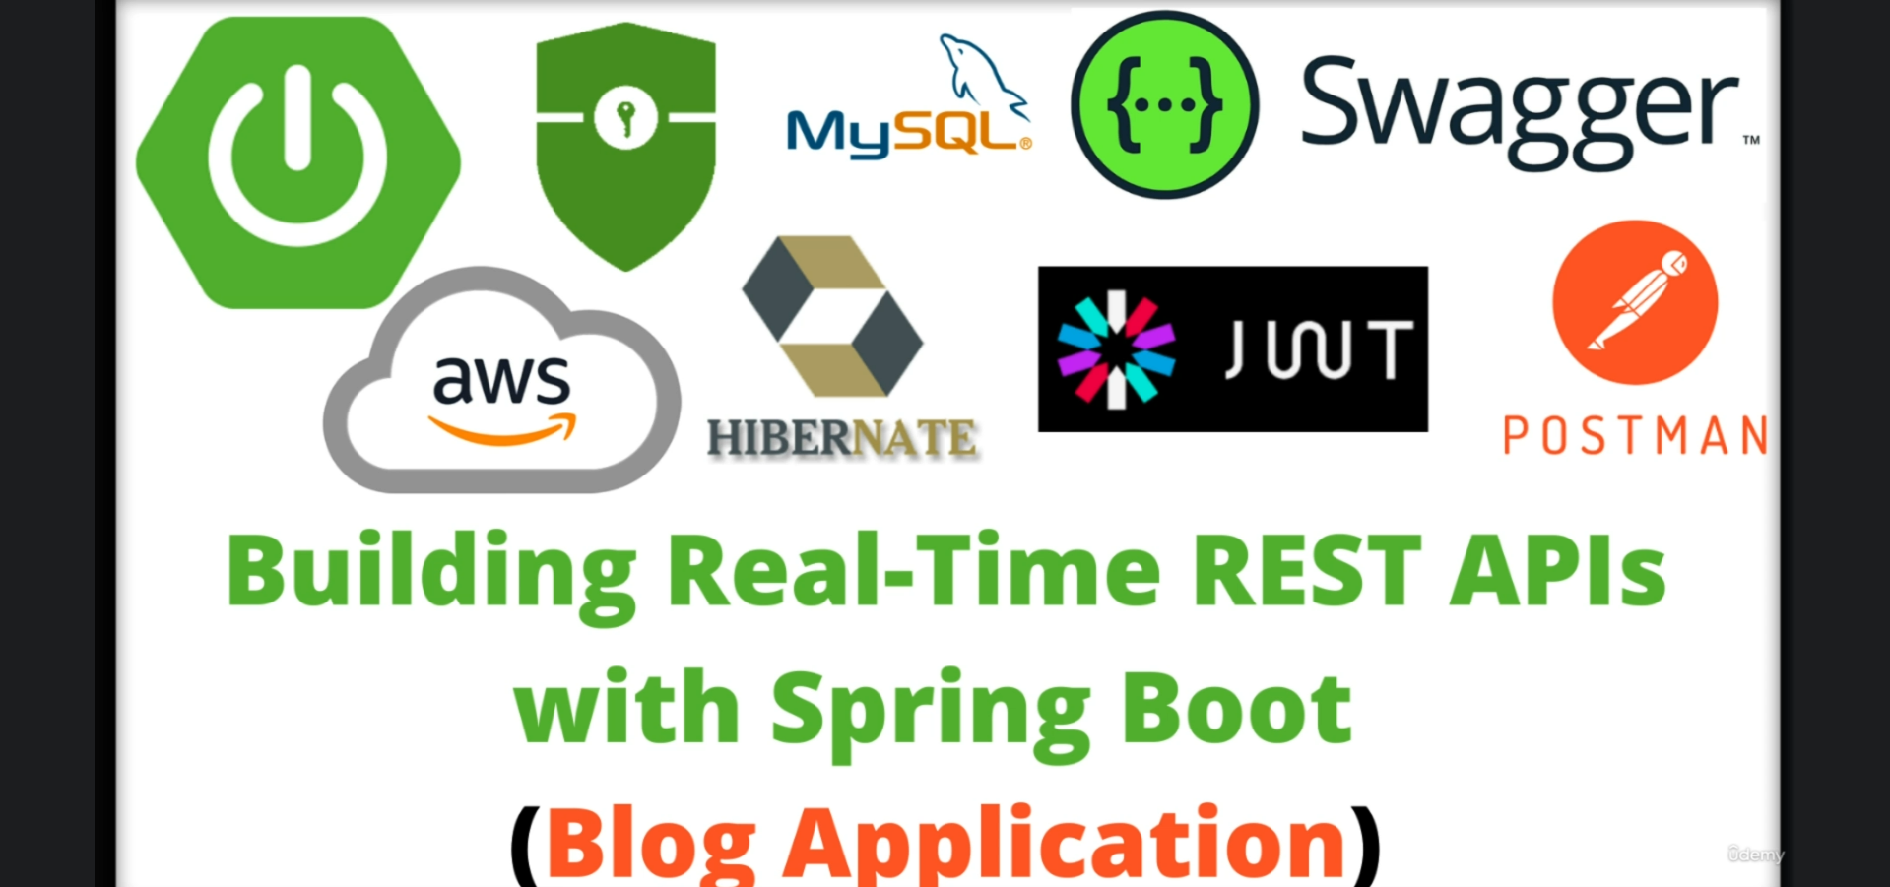
2. 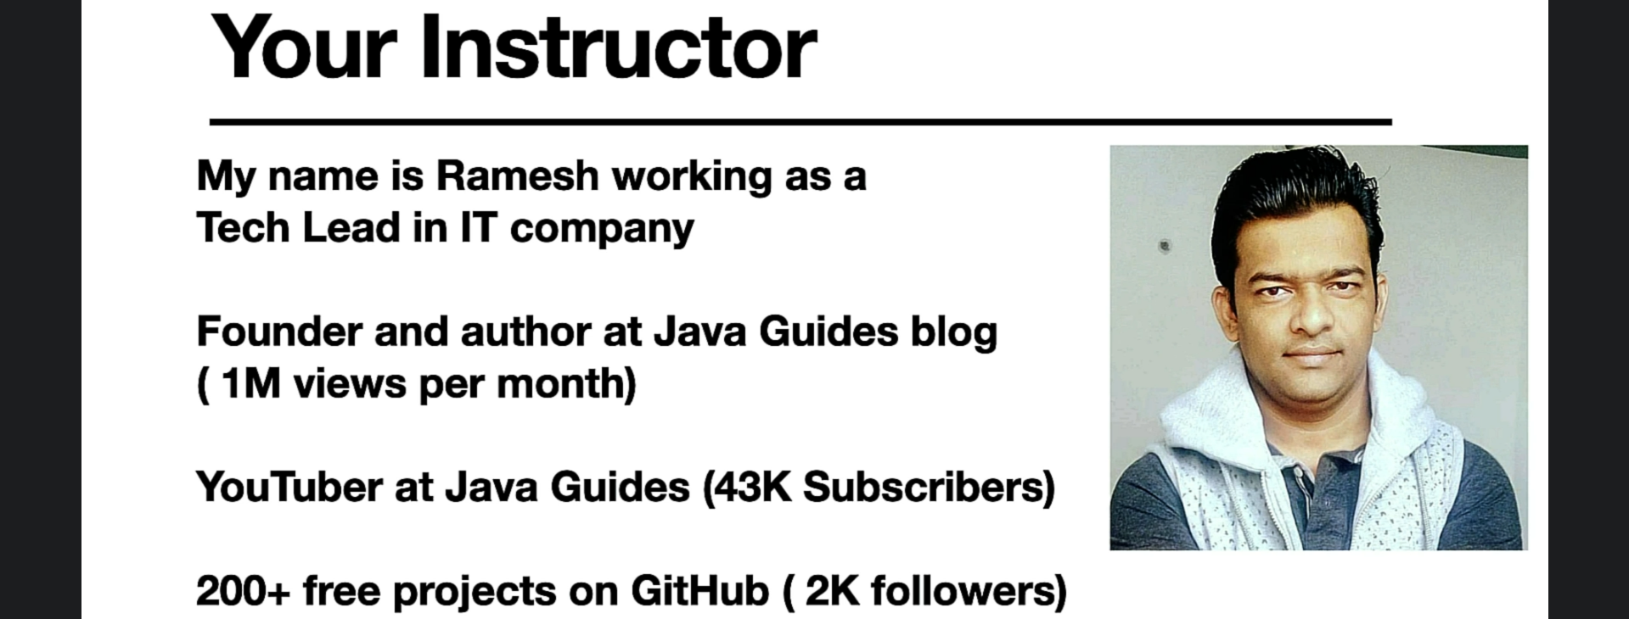
3. 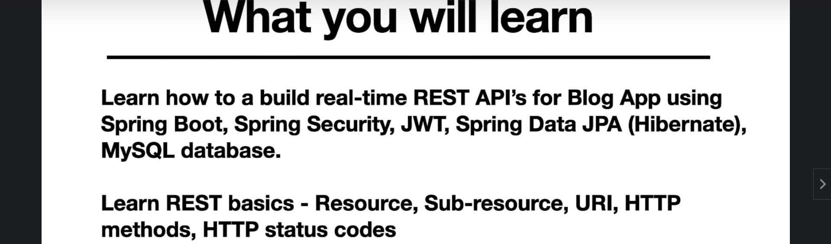
4. What you will learn
   1. How to build REST API using real-time industry standard approach.
   2. How to develop REST Endpoints for different resources.
   3. How to build login API using JWT.